**‹JavaScript – Tutorial**

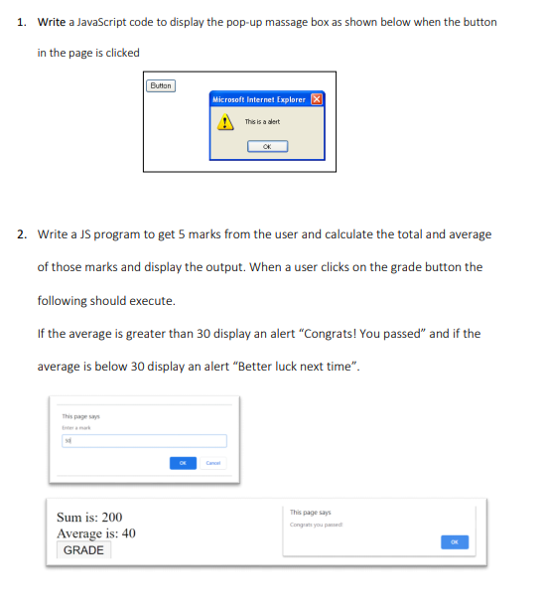

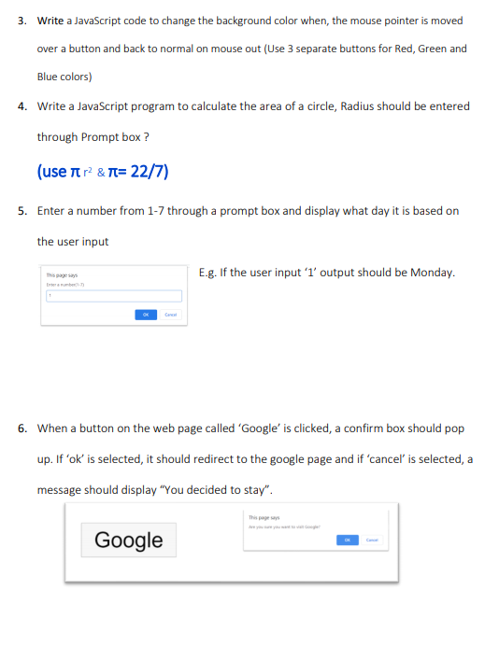

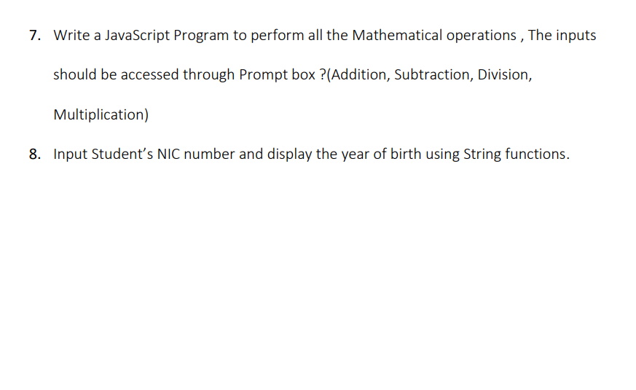**01.**

**<html>**

**<head><title>Tutorials </title>**

**<script type="text/javascript">**

**function fun() {**

**alert("This is a alert");**

**}**

**</script>**

**</head>**

**<body>**

**<form>**

**<input type="button" value="Button" onclick="fun();"/>**

**</form>**

**</body> </html>**

**02.**

**<!DOCTYPE html>**

**<html>**

**<head>**

**<title>Grade Calculator</title>**

**</head>**

**<body>**

**<h1>Grade Calculator</h1>**

**<label>Enter 5 Marks:</label><br>**

**<input type="number" id="mark1" /><br />**

**<input type="number" id="mark2" /><br />**

**<input type="number" id="mark3" /><br />**

**<input type="number" id="mark4" /><br />**

**<input type="number" id="mark5" /><br />**

**<button onclick="calculateGrades()">Calculate</button>**

**<script>**

**function calculateGrades() {**

**const mark1 = parseFloat(document.getElementById("mark1").value);**

**const mark2 = parseFloat(document.getElementById("mark2").value);**

**const mark3 = parseFloat(document.getElementById("mark3").value);**

**const mark4 = parseFloat(document.getElementById("mark4").value);**

**const mark5 = parseFloat(document.getElementById("mark5").value);**

**const totalMarks = mark1 + mark2 + mark3 + mark4 + mark5;**

**const average = totalMarks / 5;**

**alert(`Total Marks: ${totalMarks}\nAverage: ${average.toFixed(2)}`);**

**if (average > 30) {**

**alert("Congrats! You passed.");**

**} else {**

**alert("Better luck next time.");**

**}**

**}**

**</script>**

**</body>**

**</html>**

**03.**

**<!DOCTYPE html>**

**<html>**

**<head>**

**<title>Change Background Color on Hover</title>**

**<style>**

**button {**

**padding: 10px;**

**font-size: 16px;**

**cursor: pointer;**

**}**

**</style>**

**</head>**

**<body>**

**<h1>Change Background Color on Hover</h1>**

**<button id="redButton" onmouseover="changeColor('red')" onmouseout="resetColor('red')">Red</button>**

**<button id="greenButton" onmouseover="changeColor('green')" onmouseout="resetColor('green')">Green</button>**

**<button id="blueButton" onmouseover="changeColor('blue')" onmouseout="resetColor('blue')">Blue</button>**

**<script>**

**function changeColor(color) {**

**const button = document.getElementById(color + "Button");**

**button.style.backgroundColor = color;**

**}**

**function resetColor(color) {**

**const button = document.getElementById(color + "Button");**

**button.style.backgroundColor = "";**

**}**

**</script>**

**</body>**

**</html>**

**04.**

**<!DOCTYPE html>**

**<html>**

**<head>**

**<title>Calculate Area of a Circle</title>**

**</head>**

**<body>**

**<h1>Calculate Area of a Circle</h1>**

**<label>Enter the radius of the circle:</label>**

**<input type="number" id="radius" />**

**<button onclick="calculateArea()">Calculate</button>**

**<p id="result"></p>**

**<script>**

**function calculateArea() {**

**const radius = parseFloat(document.getElementById("radius").value);**

**if (isNaN(radius)) {**

**alert("Please enter a valid number for the radius.");**

**return;**

**}**

**const area = Math.PI * Math.pow(radius, 2);**

**document.getElementById("result").innerText = `The area of the circle is: ${area.toFixed(2)}`;**

**}**

**</script>**

**</body>**

**</html>**

**05.**

**<!DOCTYPE html>**

**<html>**

**<head>**

**<title>Day of the Week</title>**

**</head>**

**<body>**

**<h1>Day of the Week</h1>**

**<button onclick="getDayOfWeek()">Enter a number from 1 to 7</button>**

**<p id="result"></p>**

**<script>**

**function getDayOfWeek() {**

**const userInput = prompt("Enter a number from 1 to 7:");**

**const dayOfWeek = parseInt(userInput);**

**if (isNaN(dayOfWeek) || dayOfWeek < 1 || dayOfWeek > 7) {**

**alert("Invalid input. Please enter a number from 1 to 7.");**

**return;**

**}**

**const days = ["Sunday", "Monday", "Tuesday", "Wednesday", "Thursday", "Friday", "Saturday"];**

**const selectedDay = days[dayOfWeek - 1];**

**document.getElementById("result").innerText = `The day is: ${selectedDay}`;**

**}**

**</script>**

**</body>**

**</html>**

**06.**

**<!DOCTYPE html>**

**<html>**

**<head>**

**<title>Confirm Box Example</title>**

**</head>**

**<body>**

**<h1>Confirm Box Example</h1>**

**<button onclick="redirectToGoogle()">Google</button>**

**<script>**

**function redirectToGoogle() {**

**const confirmation = confirm("Do you want to visit Google?");**

**if (confirmation === true) {**

**window.location.href = "https://www.google.com";**

**} else {**

**alert("You decided to stay.");**

**}**

**}**

**</script>**

**</body>**

**</html>**

**07.**

**<!DOCTYPE html>**

**<html>**

**<head>**

**<title>Math Operations</title>**

**</head>**

**<body>**

**<h1>Math Operations</h1>**

**<button onclick="performOperations()">Perform Operations</button>**

**<script>**

**function performOperations() {**

**// Get the two numbers from the user**

**const num1 = parseFloat(prompt("Enter the first number:"));**

**const num2 = parseFloat(prompt("Enter the second number:"));**

**// Check if the input is valid**

**if (isNaN(num1) || isNaN(num2)) {**

**alert("Invalid input. Please enter valid numbers.");**

**return;**

**}**

**// Perform operations**

**const addition = num1 + num2;**

**const subtraction = num1 - num2;**

**const multiplication = num1 * num2;**

**// Check for division by zero**

**let division;**

**if (num2 === 0) {**

**division = "Division by zero is not allowed.";**

**} else {**

**division = num1 / num2;**

**}**

**// Display the results**

**const result = `Addition: ${addition}\nSubtraction: ${subtraction}\nMultiplication: ${multiplication}\nDivision: ${division}`;**

**alert(result);**

**}**

**</script>**

**</body>**

**</html>**

**08.**

**<!DOCTYPE html>**

**<html>**

**<head>**

**<title>Extract Birth Year from NIC</title>**

**</head>**

**<body>**

**<h1>Extract Birth Year from NIC</h1>**

**<label>Enter your NIC number:</label>**

**<input type="text" id="nicNumber" />**

**<button onclick="extractBirthYear()">Extract Birth Year</button>**

**<p id="result"></p>**

**<script>**

**function extractBirthYear() {**

**const nicNumber = document.getElementById("nicNumber").value;**

**// Validate the NIC number (should be 10 or 12 characters)**

**if (nicNumber.length !== 10 && nicNumber.length !== 12) {**

**alert("Invalid NIC number. Please enter a valid 10 or 12-digit NIC number.");**

**return;**

**}**

**// Extract the birth year based on the length of the NIC number**

**let birthYear;**

**if (nicNumber.length === 10) {**

**birthYear = "19" + nicNumber.substring(0, 2);**

**} else if (nicNumber.length === 12) {**

**birthYear = nicNumber.substring(0, 4);**

**}**

**document.getElementById("result").innerText = `Birth Year: ${birthYear}`;**

**}**

**</script>**

**</body>**

**</html>**